GE 401 – INNOVATIVE PRODUCT DESIGN AND DEVELOPMENT I

Hardware Progress Report II
Version 1
7.12.2012

TEAM 1

Ömer Faruk Karaayvaz 20701059 EE
Batuhan Kılıç 20802213 EE
Neris Şan Bage 20802583 IE
Özlem Karakaş 20800668 IE
Berk Eşgüner 20800297 EE

Table of Contents
Abstract.......................................................................3
Introduction...............................................................3
Hardware Design Decisions....................................3
Simulations ...............................................................4
Hardware Development Summary......................10
Technology Demonstration Test Plan................10
Conclusion...............................................................11

List of Figures
Figure 1: First Stage Amplifier Circuit Diagram................................4
Figure 2: First Stage Amplifier Input-Output Relationship............5
Figure 3: Circuit of 1st Order Lowpass Filter.....................................5
Figure 4: Frequency Response of the Filter ......................................6
Figure 5: Second Stage Amplifier Circuit Diagram ........................6
Figure 6: Second Stage Amplifier Input-Output Relationship.....7
Figure 7: Amplifier Circuit Diagram....................................................8
Figure 8: Amplifier Input-Output Relationship................................8
Figure 9: Amplifier Frequency Response...........................................9

I. Abstract
The document “Hardware Progress Report II” will try to give information on what is achieved so far, and how the rest of the development of IDS Station will be handled.

II. Introduction
Our product, Intelligent Drowsiness Sensor, is a precaution system that will detect if a driver is sleepy and alert the driver if necessary. The detection will be made through EEG signals acquired from the driver’s brain and measuring the eye blinking time of the driver. The IDS Station is responsible for amplifying the EEG signal and processing it before transmitting to Android device.

III. Hardware Design Decisions
While designing the amplifier we needed to consider that maximally EEG signal has amplitude of 100 uV. After that the signal will be fed to Arduino mini pro which has a 10 bit ADC and sensitive to 3 to 5 mVs. Therefore we aim around 2000 gain. The reason for that is to be able to see the signal on oscilloscope before proceeding with signal processing unit. We want to verify the EEG signal on oscilloscope and proceed to next step.

IV. Simulations
We have decided to proceed in a modular way therefore we have divided the amplifier circuit into three parts. The signal coming from the head will enter first stage amplifier where it will be amplified 10 times. We have decided to choose it as small as possible. Because normally we need a gain as high as 2000 and if we do it in one stage we would loose the signal over noise after the amplification. Therefore the first stage is like a pre-amplifier before the signal enters the filter. Below shown the spice simulation and the output to -50 and 50 microvolts applied to In- and In+.

Figure 1: First Stage Amplifier Circuit Diagram

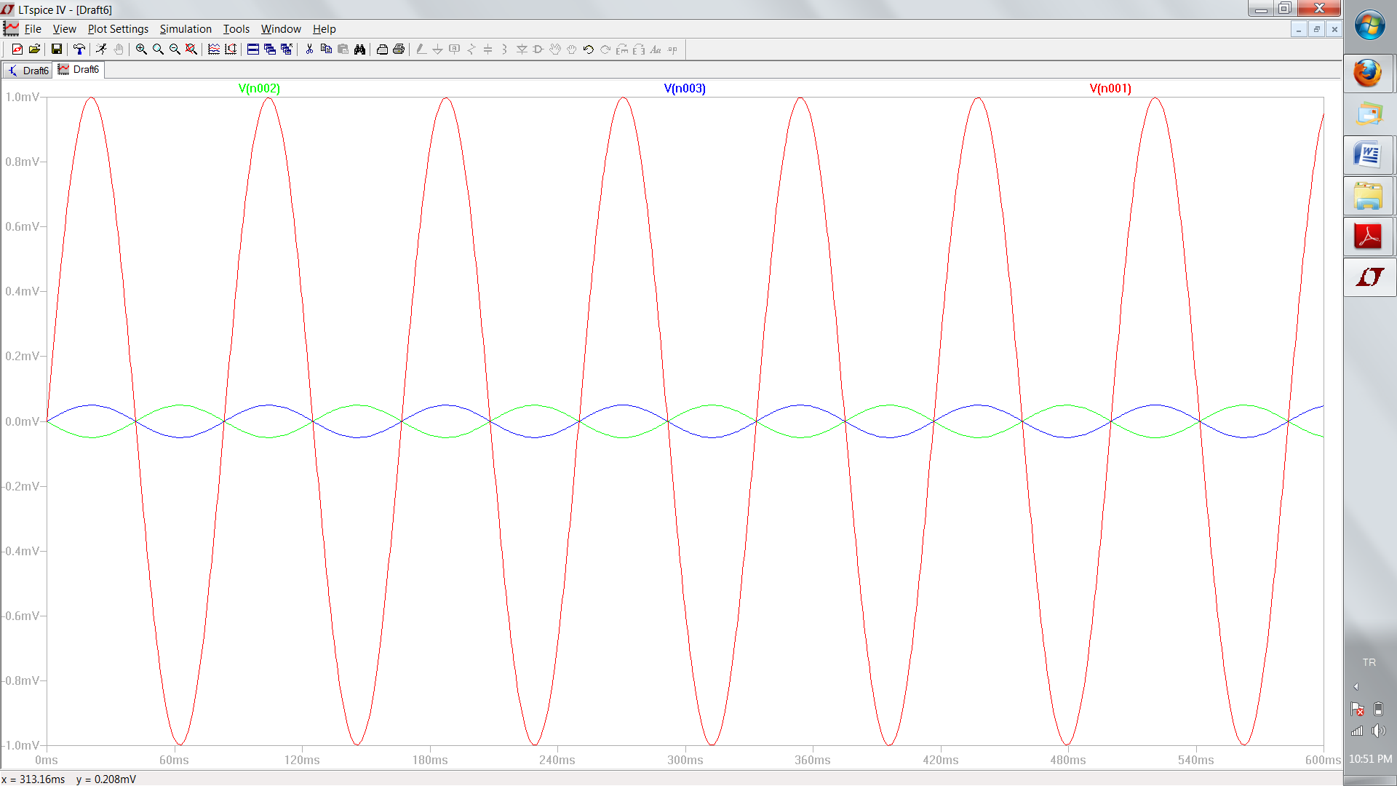
Figure 2: First Stage Amplifier Input-Output Relationship

After the first stage amplifier the signal enters the low pass filter which has a cut off frequency at 12 Hz. The reason for this filter is that it will discard any signal out of desired range.Below shown the circuitry and frequency response of the filter:

Figure 3: Circuit of 1st order Low pass filter

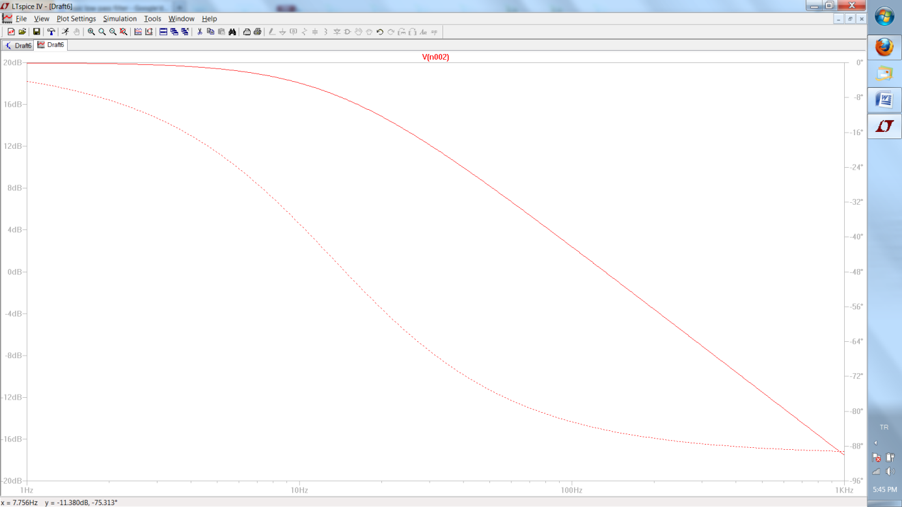
Figure 4 : Frequency Response of the Filter

Then out of the filter the signal will enter second stage amplifier to be amplified 200 times. After this amplification the signal will be ready to be fed to Arduino chip. Below shown the simulation of the second stage amplifier.

Figure 5: Second Stage Amplifier Circuit Diagram

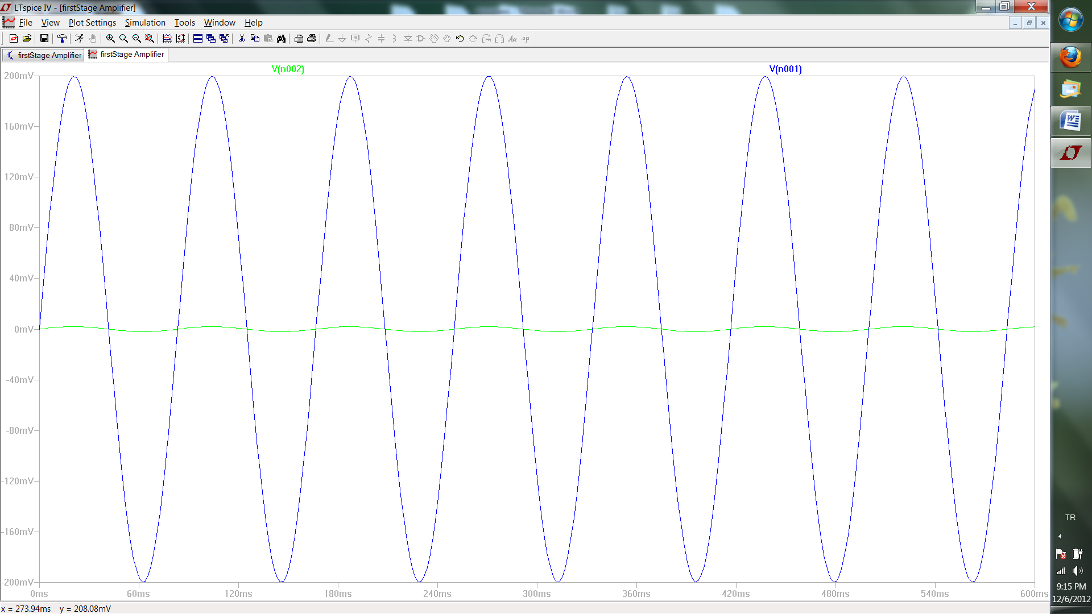
Figure 6: Second Stage Amplifier Input-Output Relationship

After the simulations has given the result we aim we constructed each part of the circuit individually and tested them. They have given the results we expected.
Until this time all the test were done by generating a 15 mV sinusodial signal from the signal generator. However, normally the signals we will be dealing with will be in orders of several 10 microvolts. Therefore, the tests were all about the funcionality of the amplifiers to measure the gain, to make sure that they will give the right amount of gain.
Following the partial tests of the components we have done the simulation of the whole circuit. Below shown the simulation and frequency response of the whole circuit.

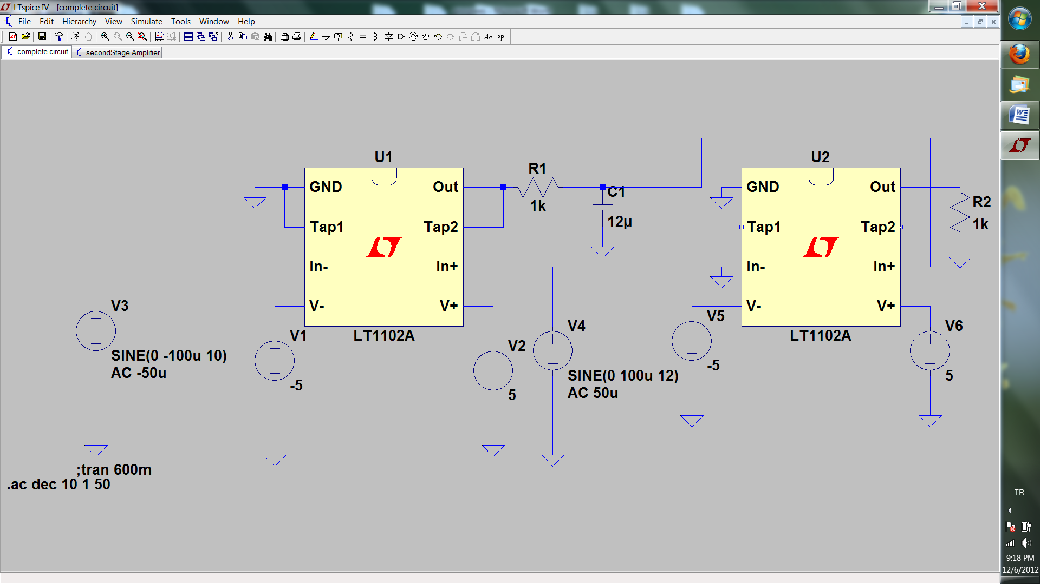
Figure 7: Amplifier Circuit Diagram

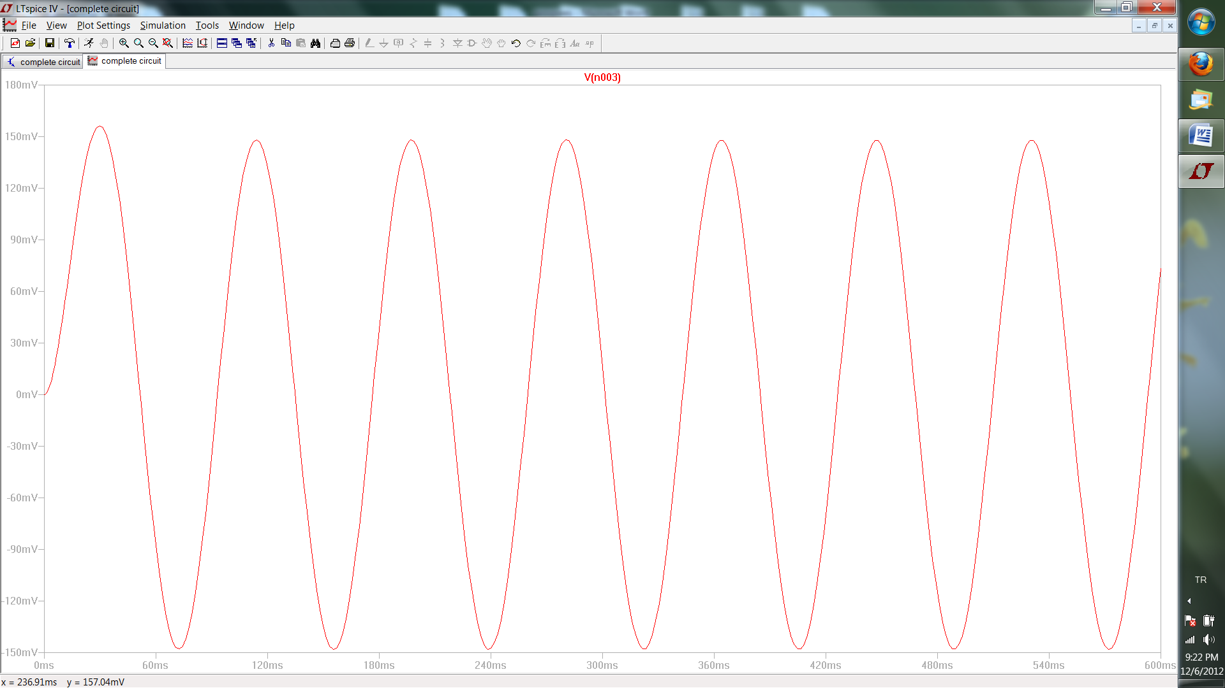
Figure 8: Amplifier Input-Output Relationship

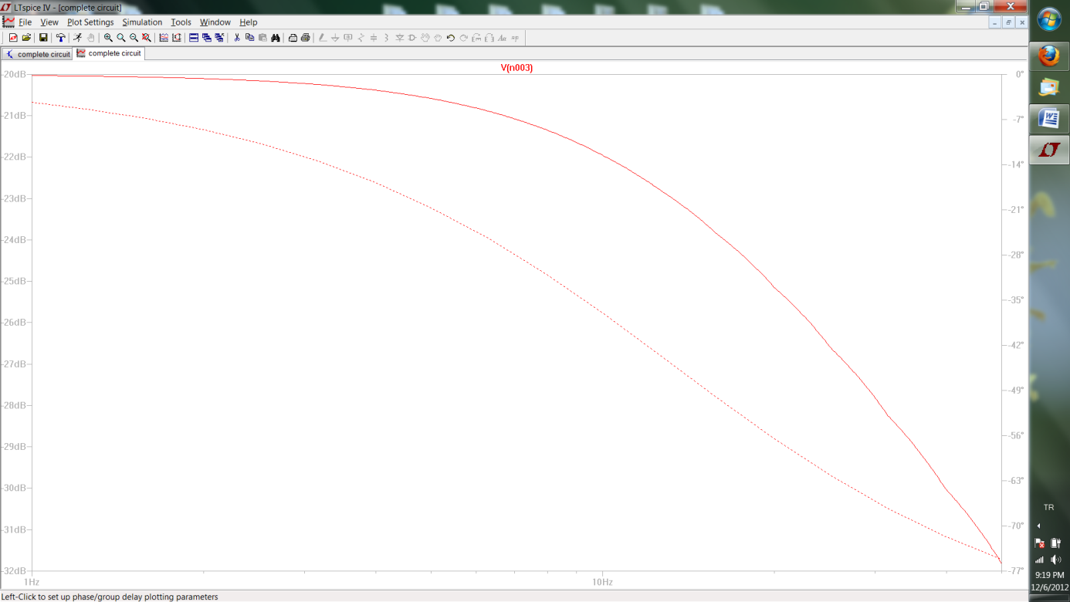
Figure 9: Amplifier Frequency Response

Then we constructed the whole circuit to test. After integrating each circuit together we examined the results. The results were all as expected.

V. Hardware Development Summary
We have simulated and tested the functionality of the parts. Only remaining task is to read the signal from the brain. We could not make a test for it since we were powering up the circuit from power supply. 50 Hz sinusodial is all seen on oscilloscope. Therefore, we decided to use voltage regulators and power them up with serially connected batteries.(In the future from the car)

VI. Technology Demonstration Test Plan
At the end of the semester we are planning to present a circuitry and we want that circuitry to amplify the raw EEG signal to a level that we can see it on the oscilloscope.
On the presentation the person the electrodes are connected, will be asked to do certain things that we know of has an immediate effect on EEG signal like blinking.

VII. Conclusion
Through the documentation we have prepared, we managed to define the working environment of our product, as well as the specifications to satisfy the customer expectations. We decided on some crucial designs needed for the operation of our hardware.
The main risk remaining in the implementation of our project is the possibility of noise we are not prepared for. To get rid of the this problem we use batteries instead of power supply, have active electrodes rejecting RF interference and opamps with very low CMRR. To handle this problem, we may add some filters or go for some design changes.
The main difficulty in the implementation of our project was the elimination of the 50 Hz signal in tests.. The problem is that normally after completing the device the environment it will run will not have 50 Hz noise however, while doing the tests there is high exposure. Therefore, we decided on regulators and batteries.

