GE 401 – INNOVATIVE PRODUCT DESIGN AND DEVELOPMENT I

Preliminary Design and Subassembly Specification Report
Version 1
30.11.2012

TEAM 1

Ömer Faruk Karaayvaz 20701059 EE
Batuhan Kılıç 20802213 EE
Neris Şan Bage 20802583 IE
Özlem Karakaş 20800668 IE
Berk Eşgüner 20800297 EE

Table of Contents
Abstract...............................................................2
Introduction.......................................................2
Specifications of the Subassemblies..............4
Quality Characteristics...................................16
Conclusion........................................................19
References.........................................................20
List of Figures and Tables
Table 1 : BOM Table of IDS Headband........................................5
Table 2 : BOM Table of IDS Station..............................................9
Table 3 : BOM Table of Charging Dock.....................................11
Figure 1 : Subassembly Diagram of IDS......................................3
Figure 2 : Subassembly Diagram of IDS Headband..................4
Figure 3 : Subassembly Diagram of IDS Station........................6
Figure 4 : Flow Chart of EEG Signal.............................................8
Figure 5 : Subassembly Diagram of Charging Dock...............10
Figure 6 : Decision Tree for Eye Blinking Time.......................12
Figure 7 : Decision Making Algorithm.......................................13
Figure 8 : QFD.................................................................................13

I. Abstract
This document consists of the subassemblies of IDS (Intelligent Drowsiness Sensor), the specifications of the subassemblies and some flow-charts, algorithms to guide implementation. The specifications of the subassemblies and the subassemblies may be subject to change, but this document aims to provide necessary information for the implementation of IDS. This document embodies the subassembly configuration for Intelligent Drowsiness Sensor in addition to an up-to-date QFD house of our product and explanations regarding how the qualities standing there are achieved in engineering terms.

II. Introduction
Subassembly specification, as the next step for the implementation of the Intelligent Drowsiness Sensor will give information about how the blocks of IDS will should be built. The BOM tables aim to provide information for configuration management.
The consumer expectations from our product were described in the “Product Requirements Document”. This document aims to guide the production of IDS (Intelligent Drowsiness Sensor) to fulfil the customer needs. The QFD house for IDS was introduced in the “Product Requirements Document”; and this document holds information about how the customer needs are satisfied in engineering terms.

The success of any product is directly related to the satisfaction of customer needs. This document aims to describe by which means the customer expectations will be satisfied via explaining how the qualities in the top row of the QFD house is achieved..

Electrodes
21011
Headband
22011
IDS Station 3011
AmplifierCircuit
31011
Bluetooth Module
33011
SignalProcessingUnit
32011
12V to 5V Transformer
41011
Mini USB
42011
Android Device 5011
ChargingDock 4011
IDS Headband 2011
IDS
1011

Figure 1 : Subassembly Diagram of IDS

III. Specifications of the Subassemblies
1.IDS Headband
Headband
22011
Electrodes
21011
IDS Headband 2011

Figure 2: Subassembly Diagram of IDS Headband
An easy to use headband will keep the electrodes together. The headband consists of two electrodes and the cotton headband.

1.1 Headband
Main function of the headband is to hold the electrodes to acquire the EEG signal. The specifications of the headband is as follows:
- Made of silk or cotton to provide ease of usage.
- Lightweight – at most 40 grams.
- Radius adjustable between 7-14cm, maximum thickness of 3 mm (excluding the thickness of the electrodes) and width of 4 cm.

1.2 Electrodes
2 active electrodes will be used to gather EEG signals from the driver. Electrodes will be placed in the driver’s forehead, and will have stable positions on the headband.
The specifications of the electrodes will be used is as follows:
- Active electrodes, suitable for gel-free usage.
- Input impedance of 5 mega ohm
- Operating temperature of -10 ~ 45 °C
- Current drawn: 10 uA
Assembly Stock Number |  | 2011
Assembly Part Description |  | IDS Headband
Stock Number | Part Description | Number Used
21011 | Active Electrodes | 2
22011 | Headband | 1
Drawing No | 2011-BOM
Prepared By | Batuhan Kılıç
Checked By | Neris Şan Bage
Date | 29.11.2012

Table 1 : BOM Table of IDS Headband

2. IDS Station
Bluetooth Module
33011
SignalProcessingUnit
32011
AmplifierCircuit
31011
IDS Station 3011

Figure 3: Subassembly Diagram of IDS Station

The IDS station will be placed behind the seat of the driver, receiving the inputs from the electrodes via coaxial and shielded wires. The IDS Station will host three modules; the amplifier circuit, signal-processing unit and the Bluetooth module.
Specifications of the IDS Station is as follows:
- Dimensions of 4 cm x 7 cm x 15 cm.
- Input voltage is 12V

2.1 Amplifier Circuit:
The amplifier circuit will be utilized to amplify the low amplitude EEG signal (10- 100 microvolts) to enable further processing of the EEG further signal.

Specifications of the amplifier circuit is as follows:
- Input voltage will be 12 volts
- Target gain is 1500
- Input current is
- Operating temperature of -10 ~ 45 °C

2.2 Signal Processing Unit
An Arduino mini pro chip will be used as the signal-processing unit. The Arduino chip will be used to count the zero-crossings to determine the frequency of the EEG signal. We have found out that checking the zero crossings of the amplified EEG signal may result in over counting the zero crossings, therefore a certain threshold value (such as 2V) should be chosen as the basis instead of zero.
Specifications of the signal processing unit is as follows:
- Operating voltage is 5V
- DC current demand of 40mA
- Clock speed of 8 MHz
- Memory of 1KB
- Operating temperature of -10 ~ 45 °C
- The decision tree for EEG signal classification is given below

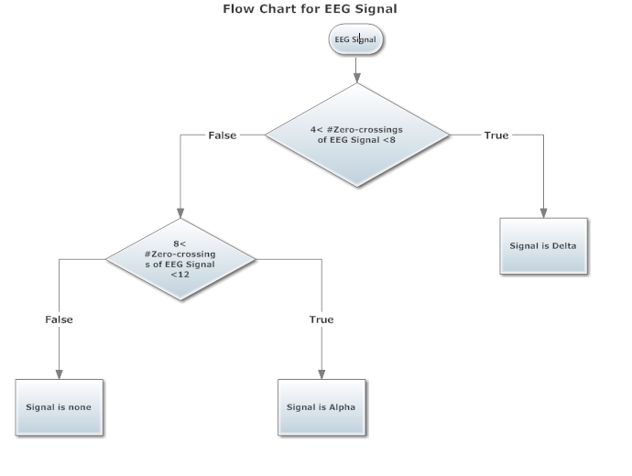
Figure 4: Flow Chart of EEG Signal

2.3 Bluetooth Module:
The Bluetooth module will maintain communication between the IDS Station and the Android device. Number of the zero crossings will be passed every second to the android device.
Specifications of the Bluetooth module is as follows:
- Supports Bluetooth v2.0
- Input voltage of 3.3V

- SIG, ICS and CE certified
- PCB mountable
- Operating temperature of -10 ~ 45 °C

Assembly Stock Number |  | 3011
Assembly Part Description |  | IDS Station
Stock Number | Part Description | Number Used
31011 | Amplifier Circuit | 1
32011 | Signal Processing Unit | 1
33011 | Bluetooth Module | 1
Drawing No | 3011-BOM
Prepared By | Batuhan Kılıç
Checked By | Neris Şan Bage
Date | 29.11.2012

Table 2: BOM Table of IDS Station

3. Charging Dock
Mini USB
42011
12V to 5V Transformer
41011
ChargingDock 4011

Figure 5: Subassembly Diagram of Charging Dock

The charging dock will provide fixed positioning and charging for the Android device.
Specifications for the charging dock is as follows:
- 12 V input voltage
- Dimensions of 19 cm × 9 cm x 3 cm
- Able to host and charge an Android phone via Mini usb

4. Android Applications
Android applications part consists of a secondary sensor which checks eye blinking time, and the decision-making &alarming part. The IDS Android application will not have an UI at this stage.

Assembly Stock Number |  | 4011
Assembly Part Description |  | Charging Dock
Stock Number | Part Description | Number Used
41011 | 12 V to 5 V Transformer | 1
42011 | Mini USB | 1
Drawing No | 4011-BOM
Prepared By | Batuhan Kılıç
Checked By | Neris Şan Bage
Date | 29.11.2012

Table 3: BOM Table of Charging Dock

4.1 Eye Blink Time Detection Sensor
An application will be developed for Android operating system, to measure the eye blinking time of the driver.
Specifications for the eye blinking time sensor is as follows:
- Able to run on every android version higher than 2.3.3 (API 10)
- Input image resolution of 640x480
- Response time of 200ms

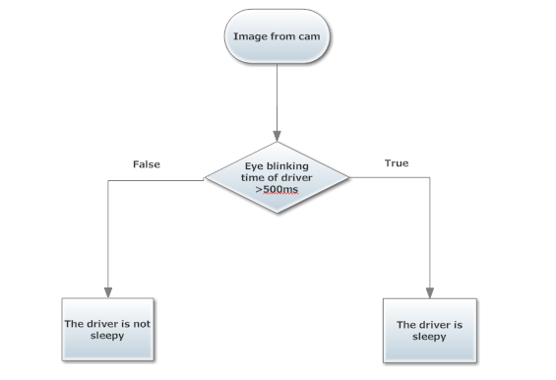
Figure 6: Decision Tree of Eye Blinking Time

4.2 Decision Making and Alarm
Combining the data from the EEG and eye blink time detection sensor, the decision making process will choose the appropriate alert level and alert the driver. No external buzzer circuitry will be used, the application will alert the driver via the android device. Output of the processed EEG signal will be received from the Bluetooth module.

Specifications of the decision making and alarm is as follows:
- Able to run on every android version higher than 2.3.3 (API 10)
- The decision-making algorithm is given below
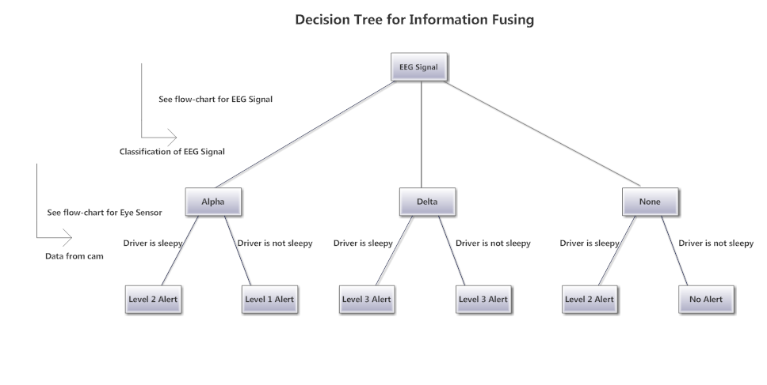
Figure 7 : Decision making algorithm

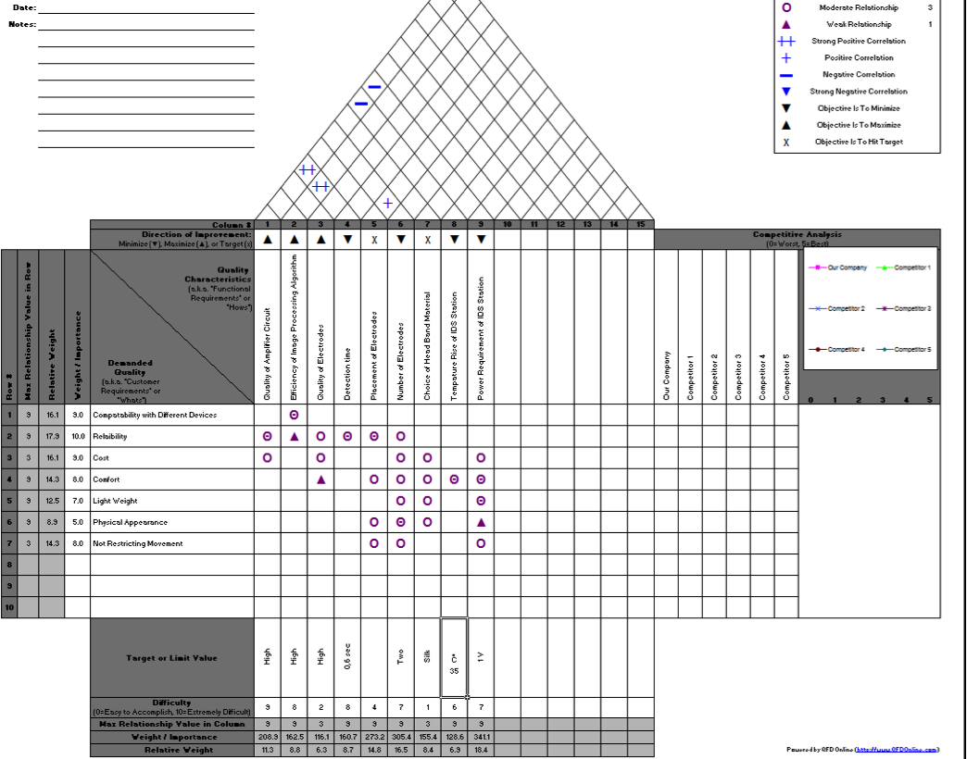
Figure 8 : QFD

IV. Quality Characteristics

Quality of Amplifier Circuit
Quality of the amplifier circuit is crucial for the operation and reliability of IDS. The amplifier circuit is designed as a two-stage amplifier including a low pass filter between the two stages. A high quality differential amplifier will be used at the first stage ensuring a clean signal by amplifying the signal by a factor of 10 in the first stage. After the first stage the higher frequency components will be eliminated by a low pass filter with a cut-off frequency of 15 Hz, and then the signal will be amplified again by a factor of 150 to get it ready for further processing. The high quality differential instrumental amplifiers are chosen because the signal we are trying to capture is highly vulnerable to noise.

Efficiency of Image Processing Algorithm
The efficiency of the image-processing algorithm is considered to be important for two reasons. With a well-designed image-processing algorithm our application will consume less processing power and therefore more Android phones will be able to run our product. The availability of our application for lower-end Android devices will definitely provide us a bigger market

The second reason that makes the efficiency of image processing algorithm important is that the processing time for each image directly affects the reliability of our product. The trade-off for quality in the captured image versus the processing time could be managed with the selections specified in the subassembly specification document. The resolutions of the images will be 640x480 provide us a reasonable processing time with an enough detailed image to detect the eye. The processing time targeted is below 200 msec.

Quality of Electrodes
Active electrodes are chosen; because they will enable us to have a cleaner signal with the circuitry is embodies. The circuitry helps rejecting RF interference among other interferences coming from the environment that may affect the signal. The use of active electrodes also enables us to use fewer electrodes, using only two electrodes the precision of measurement for the EEG signal goes up to 93%. The choice of active electrodes also makes it possible to acquire the EEG signal from the back of the head, instead of the forehead, which reduces the number of required electrodes and improves the quality of the signal in addition to providing us flexibility with the placement of probes.Using ear lobe or neck as reference, the signal can be retrieved with very low noise by active electrodes.

Placement of Electrodes
Our system must be reliable in order to be successful. The reliability is closely related to the placement of electrodes, because correct placement of electrodes will enable us to get a clean EEG signal with fewer electrodes. The ground electrode will be placed on the earlobe and the other electrode will be placed on the forehead.

Choice of Headband Material
The driver will have to wear a “headband”, which will host the electrodes that will capture the EEG signals. The material, which the headband will be made of, should be a quality material to keep the driver comfortable during long periods of usage. The material that suits this purpose is cotton. The headband will be made of cotton for the sake of user-friendliness.

Detection Probability
The researches have shown us that eye blinking time has %83 accuracy where EEG has %93 accuracy.(Farhan,Zvohna) The researches have indicated the cases both tests fail and they are independent and different. Therefore, for our system to fail, both tests need to fail and which is very a low probability around %1.1. The expected accuracy of the system is %98.9. To provide the system this accuracy all of the quality characteristics above examined carefully. Every one of them(except headband material) has direct effect on the detection probability.

Detection Time
The software will be looking at the images coming from the camera every instant and will have a timer. The moment it doesn’t see the eye it will start the timer and stop it when it sees the eye again. Right after the timer becomes 0.5 seconds it will set the alert for camera. For the hardware the chip will be fed with EEG signal every instant and since the software will have a detection time of 0.5 seconds the signal-processing unit will be looking at the EEG signal fed last 0.5 seconds. It will look at zero crossings in a sense. Since the EEG signal has too much components and some has very low amplitude we will be looking at the number of crossing of the threshold value in 0.5 seconds.(Theoretically it is 1 V but depends on the gain we can get from amplifier circuit).

V. Conclusion
This document aims to guide work division between engineers by dividing the system into subassemblies. The descriptions given for each subassembly aims to guide the implementation and provide stock number for each subassembly to simplify possible changes in design..
The customer needs are the basis of our product design. We tried to determine the customer expectations in the “Product Requirements Document”, and this document aims to make sure that the customer needs are going to be fulfilled with the design we have made so far.

This document introduces the main blocks of design and tries to introduce the ways to achieve the qualities standing in the top row of the QFD. As it can be seen from the qualities specified, our main aim is to build a reliable precaution mechanism.

VI. References
Farhan Zaidi, T.Morris, P.Blenkhorn, “Blink detection for real time eye tracking”, Journal of Network and Computer Applications (2002) pages 129-143 February 2002.
Zvohna I,Shallom ID. “Automatic detection and classification of sleep stages by multichannel EEG signal modeling”.
http://www.arduino.cc/en/Main/ArduinoBoardProMini
www.sparkfun.com/datasheets/Wireless/Bluetooth/rn-42-ds.pdf

