9

**Table of Contents**

Introduction…………………………………… 2

Product Requirements………………………. 2

Product Specifications……………………… 3

Other Companies……………………………. 4

Utilization of QFD……………………………. 4

Conclusion……………………………………. 5

Appendix ……………………………………… 6

**List of Figures and Tables**

Figure 1………………………………………. 2

Figure 2………………………………………. 3

**I. Introduction**

In this report we give detailed information about quality function deployment table and how we perform it. First of all information of product requirements are given. That is to say what the customer expects from our product is determined. Secondly we state product specifications and their target value that are mainly concluded by electrical engineers. Finally we state how we utilize the results of QFD in our product.

**II. Product Requirements**

In order to meet demands of customers, we determine product requirements. This will help us to improve our product and change some properties if necessary. While determining product requirements, surveys play an important role.

Firstly, we make a public opinion research to understand the general idea of public. After the research we will determine some requirements to conduct a survey. We talked with 30 driver and explain our product, Ids. We asked them that “What do you expect from this product?”. We generally get cost answer firstly. They give importance to the cost factor. And they also ask about reliability. “Is this a reliable system?” is the question that we get from most of them. In addition to this, most of the drivers asked that “Can we use this in every Android device?”. According to this question we form a requirement, compatibility with different devices. The other answer that we get from drivers is about comfort of the headband. They have concerns about wearing the headband comfortably. If they can move easily or if the headband is light. By using this research and adding some different requirements that we want to evaluate, we get product requirements. These are reliability, cost, and compatibility with different devices, comfort, light weight, physical appearance and not restricting movement.

After the research, we conduct survey among 50 drivers. Participants of our survey consist of 24 owner driver and 26 bus driver. In the survey we asked the importance of our product requirements. The survey that we gave to the drivers is shown in the Figure 1.



Figure 1: Survey

According to these survey results, we form the importance of these requirements. Ratings that are given to the requirements after the survey can be seen in the Figure 2.

|  |  |
| --- | --- |
|  | RATING |
| USABILITY |  |
| COST | 9 |
| COMFORT | 8 |
| COMPATIBILTY WITH DIFFERENT DEVICES | 9 |
| **PHYSICAL APPEARANCE** | **5** |
| LIGHT WEIGHT | 7 |
| PERFORMANCE |  |
| RELIABILITY | 10 |
| NOT RESTRICT MOVEMENT | 8 |

Figure 2: Ratings

**III. Product Specifications**

By considering the needs and requirements to produce our product IDSand by considering customer’s and our company Timon’s expectations from our product,we determined specifications of our product. Expectations of the customers are stated in product requirements part. In this part we explain specifications by referring requirements and we explain the relationship between them. Additionally, we state the target values.

Our product IDS observes the brain waves by the help of electrodes so quality, placement and number of the electrodes are important considerations.Not only we as Timon but also our customers want IDS to be reliable. Quality and placement of the electrodes directly affects the reliability of our product. Moreover, there is a relationship between cost and quality and number of electrodes. As the number and quality of electrodes increases, cost of IDS increases too. Additionally, number of electrodes affects the weight, comfort and physical appearance of IDS. For instance if the number of electrodes increases, the weight of the IDS gets heavy. Our objective is to maximize the quality and minimize the number of electrodes. We want the quality of electrodes as high as possible. We determined the necessary number of electrodes as two since the proper points to observe the brain waves are the two sides of forehead.

IDS observe not only brain waves but also blink of the eyes so detection time is important to increase reliability. It is important to observe the changes of brain waves and duration of the blink of an eye if a driver falls asleep. Our target is to make detection in maximum 0.6 seconds. Reaching the target value makes our product more reliable. Our objective is to decrease the detection time.

Both our company and our customer want a comfortable product. Choice of the material increases the cost. On the other hand it improves the physical appearance and comfort of IDS.

IDS detects eye blinks with a cam. There is an algorithm for android phones to make these observations. Efficiency of this algorithm improves the reliability of the product and it also makes IDS compatible with different Android phones since operating system may be different for different Android phones. Our objective is to increase the efficiency as much as possible.

Amplifier is used while observing brain waves so quality of the amplifier is important to make trustworthy detections of brain waves. It affects the reliability of IDS and also having qualitative amplifier increase the cost.

Making right detections and decreasing the possibility of wrong detections are important. High detection probability means an accurate product so our target for detection probability is 98%. To have a high value of detection probability, detectors should be qualitative which may be result in high cost.

**IV.** **Other Companies**

To evaluate product requirements we compare our company with other companies that are producing sleeping detector. The companies we selected to compare is Mercedes, Volvo, anti Sleep Pilot and Generic. We rate the relationship between these companies and product requirements. Mercedes and Volvo have car security systems in their cars as a package. In this package there is drowsiness detector. Because these are systems integrated in car system, they have not problem in terms of comfort, light weight, not restrict movement and physical appearance. And cost of them is high results from the car costs and car security system costs.

On the other hand compatiblity with different devices is not related to Mercedes and Volvo. And reliability is not too much if it is compared with our company. The other companies produce portable devices that detect sleeping. Anti Sleep Pilot is a product that is sticked on the dashboard of the car. Therefore, it has not problem in terms of comfort, physical appearance, not restrsict movement and light weight. Its cost is very low while its eliability is not enough to detect efficiently if it is compared with other devices. And it can be used in different devices. Genreic has the product, Anti Sleep Alarm. Driver put this on his ear. Reliability is not powerful because it detects sleeping from the falling head of driver. Like IDS, it has some factors in terms of comfort, light weight, not restrict movement and physical appearance. And its cost is low too. According to these ratings are given in the QFD House.

**V. Utilization of QFD**

After forming the QFD House, we make some interpretations to develop our product. You can see the QFD House in the Appendix A. Firstly, we analyse “Relative Weight” part of the QFD House to determine important product specifications. These values are determined by the relationship among product specifications and also relationship between product requirements with importance. According the QFD House of IDS, it can be conclude that “Number of Electrodes” is the most important specification of our product. The other important specification is “Placement of Electrodes”. The order of the importance of specifications is like that Quality of Amplifier Circuit, Detetction Probability, Efficiency of Image Processing Algorithm, Detection time, Choice of Head Band Material, Tempature of IDS Station, Quality of Electrodes. Therefore we should consider these while we are improving our product. The other aspect that we conclude after the results of QFD is the importance of product requirements.

Before this anlaysis we were trying to give importance to pyhsical appearance of the IDS. But after the survey we saw that customers do not give importance to pyhsical appearance.

By the part of other companies we can conclude that our company has some disadvantages as well as advantages. However, if the most important product requirement,reliability, is considered, IDS meet the need of this requirement. And these results help us in terms of marketing strategy. We should use reliabilty factor and the cost factor while marketing process.

**VI. Conclusion**

Forming QFD House and analysing the results make Timon more powerfull. Meeting the demand is the most important factor for sales. While the design and production process, we will consider these results and give importance to product specifications according to these results. In addition to this, thanks to evaluation of other companies, Timon can have a better marketing strategy.

**Appendix A**

**QFD Relationships**

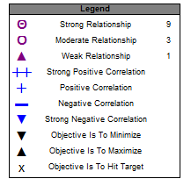

**Top of the QFD**

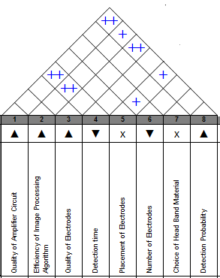

**Left Side of the QFD**

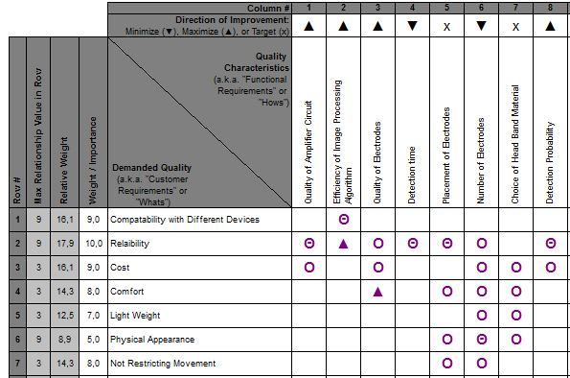

**Right Side of the QFD**

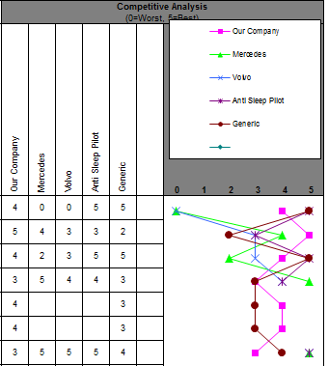

**Bottom of the QFD**

