Organizational Report
EpiWrist
Biomedicals

09.11.2010

CEO : Yalın Kasapoğlu
CFO : Cansu Akın
COO : Çağrı Can Kaynak
CMO : Taner Yıldırım
Head of IT Department : Abdullah Tanzi
Head of Hardware Development Department : Fırat Öter

ORGANIZATIONAL PLAN OUTLINE

  - EXECUTIVE SUMMARY
  - MANAGEMENT AND HUMAN RESOURCES
  - LOCATION
  - PRODUCTS AND SERVICES VIA SWOT ANALYSIS

ORGANISATIONAL PLAN

- EXECUTIVE SUMMARY
EpiWrist has been found by 6 shareholders with the aim of producing biomedical products in an innovative way with high quality. The main aim of the firm is to produce biomechanical products for epileptic people to help them live safer, more comfortable lives. The quality of epileptic people’s lives will be increased with the help of our products.
EpiWrist’s first project is to product wristlets for epileptic people to remedy the deficiency in the biomedical market of Turkey. Considering the gap in the market, the target value is to reach producing and selling approximately 50000 units/year and the break point seems to be reachable approximately in four months.
EpiWrist’s target market is the medical market, which consists of hospitals, patients and relatives of the patients. With its solution and care-seeking based products, it’s acceptable that these products are needed, will be used and help epileptic people live more comfortable lives. The company is advantageous considering the gap in the local market and the importance of health issues.
Our primary product is the product that gives its name also to the company EpiWrist. EpiWrist is a wristlet, which detects seizures of a patient when he/she is asleep. It basically detects the seizure, monitor the details (such as the date, duration etc.), ring the alarm in the next room to warn people living in the house and call the hospital if necessary. It is a complete system composed of a wireless wristlet shaped sensor, a monitor and an alarm. When the seizures occur, the data of the seizures will be kept which is an important fact for epilepsy patients to keep the disease under control. Statistical data of the patients we have found shows that such a product is needed in the market, therefore our project is expected to be sold in great numbers in a couple of months. Another advantage of the product in the market is that its competitors are expensive services such as keeping a nurse in the house and the symptoms of epilepsy cannot be observed by human senses all the times.
EpiWrist is found by research and analysis of the gaps in the biomedical market by the shareholders. Considering the great vision and innovative thinking of the equipped team of the company, sale numbers are guaranteed in an accelerated path therefore the company aims to help people live their lives in a safer, healthier, more comfortable and qualified way.

Mission:
To be the first and only producer in Turkey by designing the safest system for epilepsy patients which informs and warns relatives of the patient in case of a seizure, calls the hospital and keeps and monitors the details of the seizure to provide the safest conditions fort he patients.

Vision:
We help the patients and their families live happier, healthier and more confident lives by providing the safest sleeping conditions with the most equipped epilepsy-detecting wristlets with a fair price: for a good sleep with confidence.

Description of Business and Legal Structure
EpiWrist was established in 2010 to meet the demand for epilepsy seizure detecting, alarming and keeping the records of the seizures for the biomedical industry. The project product is an epilepsy seizure detecting system, which detects seizures of a patient when he/she is asleep. It basically detects the seizure, monitor the details (such as the date, duration etc.), ring the alarm in the next room to warn people living in the house and call the hospital if necessary. The main aim of the company is to help epileptic people and their relatives by increasing the quality of their lives with its qualified product. Company is housed in Ankara, which will provide the opportunity to access to most of the biggest hospitals in Turkey. It is a new firm that will enter the market with an innovative product that is not produced and sold in Turkey. Our ambition is to create new projects and fill the gaps in the sector with care-seeking biomedical products and to have the biggest local share of the market thinking that other innovative firms would enter the market in 5years projection, our advantageous position is that we have a talented and equipped management team which would be the leading producers of the local market.
EpiWrist is a corporation company starting with 6 shareholders since the shares will be offered to new investors and this initiative would increase the value of the company with new investments. Since our projection of sale numbers would be in an accelerated path in a couple of months, we would be able to take attention of new investors and the perception of banks would be positive. The company’s capital structure is thought to be limited ownership and 50 percent of the capital can be a long-term loan and also Ministry of Health has grants for succesfull projects.

- MANAGEMENT AND HUMAN RESOURCES

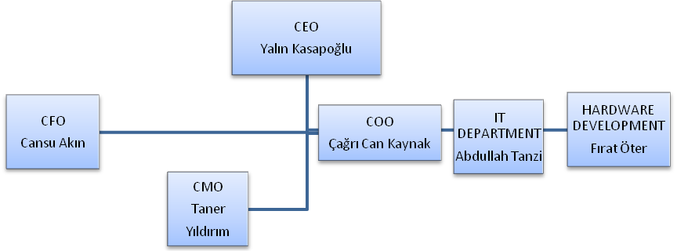

Yalın Kasapoğlu,
CEO (Chief Executive Officer): He advises the strategies and organizations as a leader. He grants motivation to employees and builds the interface between the firm and the community. He sets up the budgets within the firm, organizes the funds of the projects, and manages financial and human resources, organizational and operational decision processes. He sets up the Board. He ensures employees, creates and looks for future opportunities.
Cansu Akın,
CFO (Chief Financial Officer): She is responsible of developing the financial planning, provides internal d external financial reports, cost and revenue analysis and accounting. In this direction he does the financial planning, cost and revenue analysis and accounting. Risk management, shareholder relation policies and procedures are also under her responsibility. She directly reports to the CEO.

Taner Yıldırım,
CMO (Chief Marketing Officer): He is responsible of marketing, product development and researches. He is responsible of market searches, how to operate and behave in the market and estimates tendencies of the market and the expectations of the customer.
Çağrı Can Kaynak,
COO (Chief Operations Officer): He is responsible of management of all strategic and operational activities of the company. Creating the value of inputs is under his responsibility. Improvement of the quality of the services and products, securing the facilities and the operations are his other main duties. He reports to the Board. The IT and Hardware Development Department are under his advise and management.
Abdullah Tanzi (Head of IT Department) , Fırat Öter (Head of Hardware Development Department) :
These are engineering departments, responsible of developing the software and hardware designs. Head of IT Department has the responsibility of following up the latest technological developments in the sector, analyses and process the necessary procedures within the company while the Head of Hardware Development Department have to make sure that his department produces the hardwares with the company’s strategy and satisfies the company by means of all hardware sources.

3. LOCATION

The headquarters of the company is in Ankara since it is the capital of Turkey and has the most health-service based facilities. Location planning is a part of the marketing plan and would be included in the marketing plan with the supply chain planning. We may have the disadvantage of human resources since İstanbul is in an advantageous situation from this perspective and the location of the company would be analyzed detailed in marketing plan.

- PRODUCT AND SERVICE ANALYSIS
Analyze of Creation of Our Company in the Market
Strengths:
- The management team is committed and confident.
- Our primary product is qualified and reliable.
- Our product’s performance is superior to its competitors, has extra specifications than others.
- Our product can be used life-long.
- The management is qualified and equipped about IT, hardware development, manufacturing and systems engineering.
- Our product will help the patients, make their life easier, it is a needed product.
Weaknesses:
- We do not have direct mass production nor marketing experience.
- We might start with a limited budget compared to other companies in the market.
- Epilepsy’s all aspects could not have understood yet by medicine so we do not have enough knowledge of other symptoms of the disease.
- We need a technical support service for the customers.
- We should have more multi-city located system to serve in the health market.

Opportunities:
- We can design and develop new products and projects.
- Biomedical market is expanding rapidly with the developments in both medicine and technologies.
- Biomedical products are needed products and new shareholders and funds can easily invest successful projects.
- Our local competitors do not produce equivalent nor similar products.
- We can sell our product worldwide.
- Our expected sale numbers are high.
Threats:
- We may have difficulties about legislation since our product is a health-based product and the bureaucracy of Turkey is hard to cope.
- Although our product does not have any equivalent in the local market, there are other companies, which have the market power.
- There are too little financial analyses about the market. Although we are trying to find necessary information, we just can reach to data from informal sources.
- Developments in the biomedical sector can affect our company.
- Existing competitor firms may produce similar products in a short time.
- Since The biomedical healthcare sector relies on a wide range of supporting
sectors there are not exact istatistics about the financial and marketing issues to make
our exact plannings and estimations.

