

SUNBURST TECHNOLOGY CORPORATION
Team #1 Sunflower

DEVELOPMENT PLAN
21.02.2011

İrem Akdaş-IE Ali Öztaş-CS Betül Örün-EE
20602266 20701569 20700796

Nil Tuğçe Patan-IE(MAN) Berkay Öğdük-CS Tuğçe Kartalkanat-EE
20603256 20702282 20603276

Bilkent University
06800 Ankara
Version 2

TABLE OF CONTENTS
- Introduction………………………………………………………... 3
- Explanation of Workpackages………………………………….......4
  - Institutional Works…………………………………………….4
  - Research……………………………………………………….5
  - Business Plan…………………………………………………..6
  - Engineering…………………………………………………….7
  - Implementation………………………………………………...8
  - Testing………………………………………………………….8
  - Marketing Plan…………………………………………………9
  - Industrialization……………………………………………….10

1. Introduction
In order to get better results in the projects there must be clarified time allocation to each job. All of the jobs must be divided into subheadings and their precedence must be specified in addition to their duration. Therefore, development plan mainly aims to demonstrate job sequence and provide us consistency.
Our development plan has 8 Workpackages. All of the jobs are classified under one of them. In order to get better understanding, explanation of the each Workpackages and their Gantt Chart takes place herein. Weekends and official holidays are considered as working days since we have opportunity to work on continuously.

2. Explanation of Workpackages
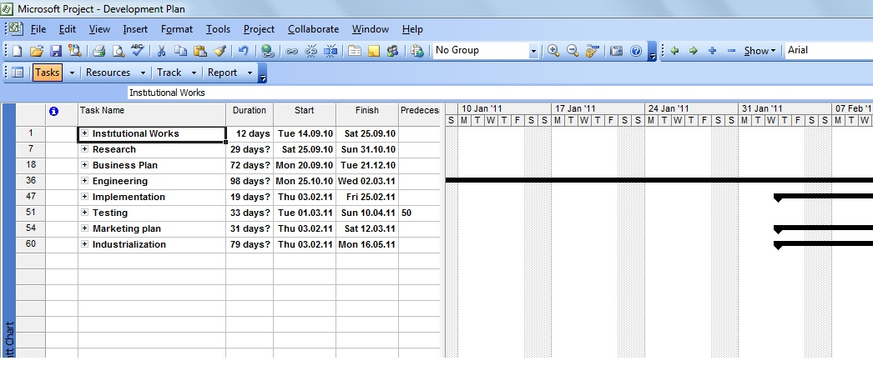
Figure 1: General Overview of Workpackages
2.1 Institutional Works
This part starts from the deciding project idea and involves pre-proposal process. After determining the idea, the next step is to write pre-proposal. The approval of pre-proposal is the waiting time to start the project. Determining the company name and job division is done sequentially by all group members.
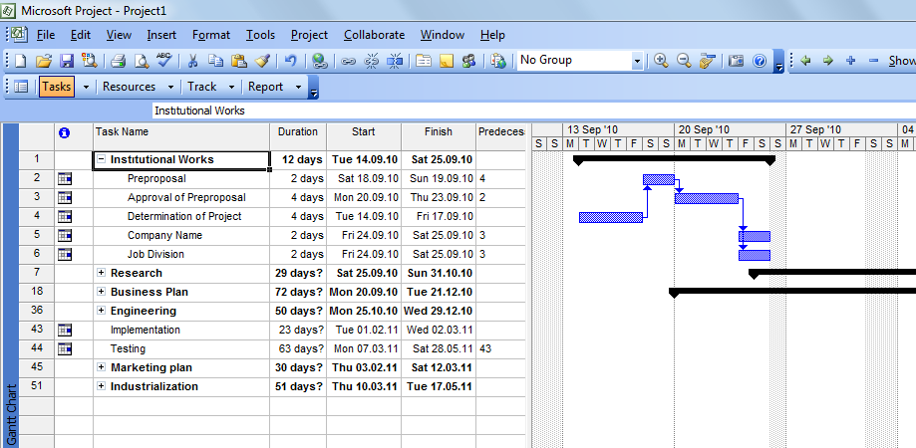
Figure 2: Institutional Works Gantt Chart

2.2 Research
In order to get more accurate results and depth analyses we divided research part into 3 subheadings: marketing research, software research and hardware research.
Entering the market with a new innovative product requires huge importance. Taking it into consideration, we started to focus on competitor analyses. By evaluating the results competition report and literature survey is written by İrem Akdaş.
Hardware research is mainly done by Betül Örün and Tuğçe Kartalkanat. Hw search and Hw block diagram is completed. Our first project idea was same with the beginning one but the components of it changed. Therefore, these diagrams are done with more than one version.
Software research is done at the same time with the hardware research by Ali Öztaş and Berkay Öğdük. User interface and SW flow chart is the subheading of that part and in accordance with the HW block diagram.
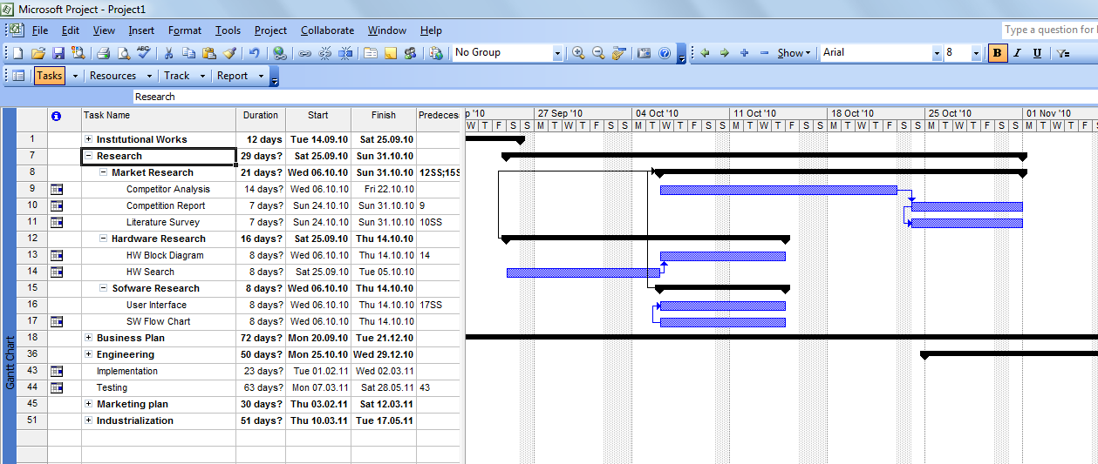
Figure 3: Research Gantt Chart

2.3 Business Plan
Business plan includes organizational plan, financial plan and marketing plan. Therefore, these subheadings are focused on individually and making them as general form is stated as general form.
Organizational plan requires organizational schema, determination of location, products&services, future plans and performance measure. Financial plan includes financial analyses, balance sheet, break even, financial ratios, income statements and assets. All of the jobs must be done in accordance with the others and therefore precedence rule is applied in the Gantt chart. After marketing analyses part, all the subheadings are combined as general form and business plan ends at 21.12.2010. Business plan is focused on by all group members but written by Nil Tuğçe Patan.
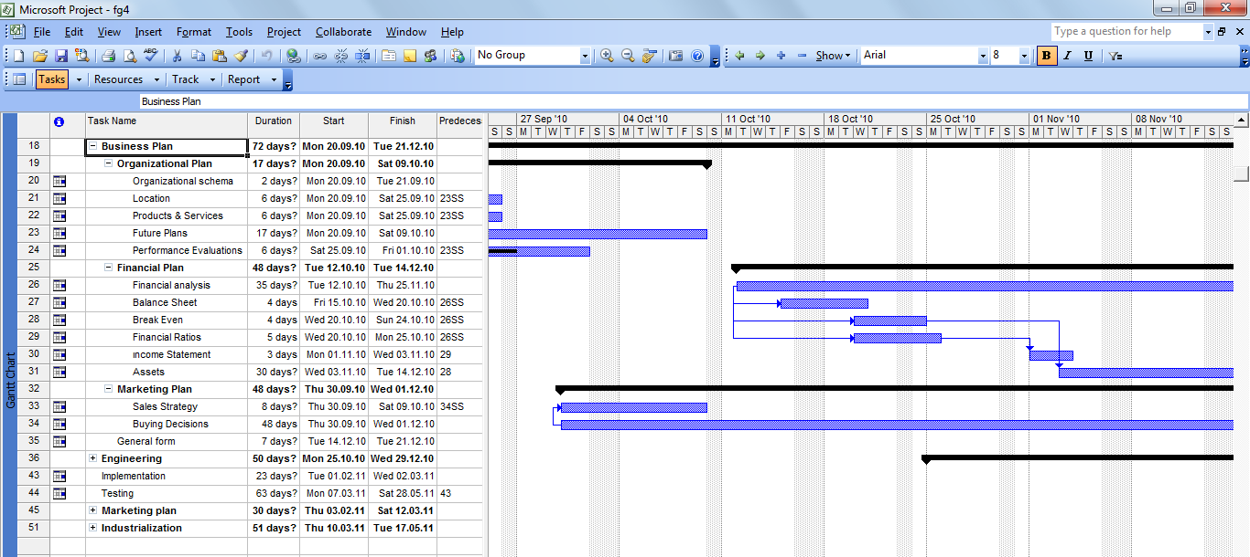
Figure 4: Business Plan Gantt Chart

2.4 Engineering
Engineering part mainly focuses on product qualifications in fall semester. Product definition, product specification, subassembly specifications, product definition with QFD have to be done. Therefore start-to-start, start-to-finish and such kind of clarifications are given importance in the Gantt chart. All of the reports are revised according to group decision and advisor help. Each of them has more than one version. This part ends with web page designs at 29.12.1020 and waits for implementation part until the spring semester.
VHDL modules and mechanical designs are done by engineering students as well as implementation of analog circuit. They are followed by building PCB. The improvements are coordinated with the implementation part. So, the allocated time is clarified according to the coordination of the Workpackages.

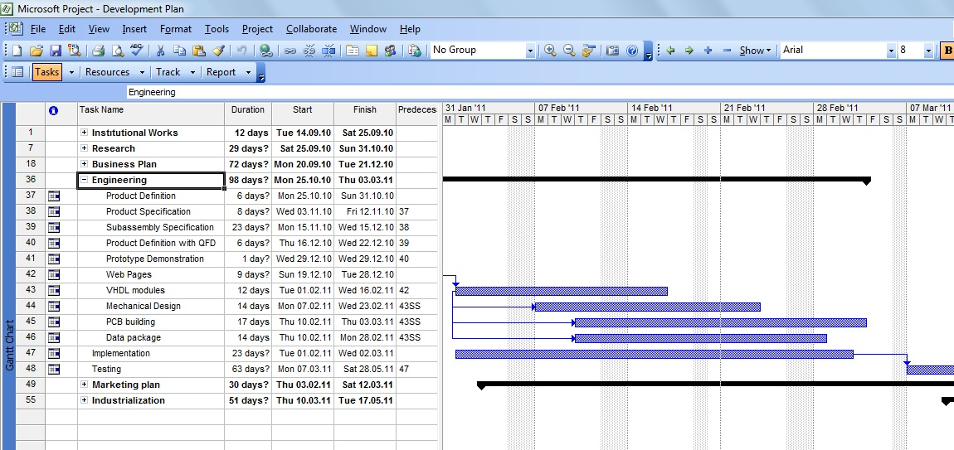
Figure 5: Engineering Gantt Chart

2.5 Implementation
The implementation part mainly contains implementation of analog circuit, layout, mechanical design and engineering data package as illustrated in the progress of GE402. This duration has too much importance on the final product. Therefore, it is aimed to allocate it approximately 4 weeks. The exact duration of implementation is clarified as 19 days.
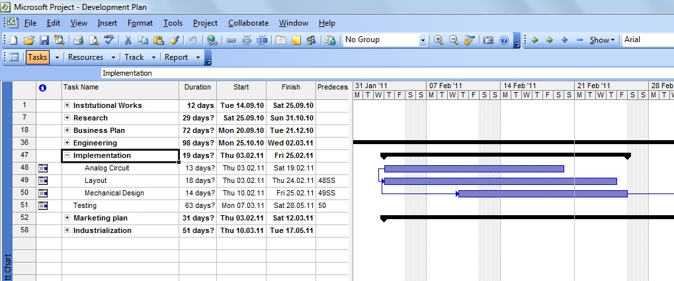
Figure 6: Implementation Gantt Chart

2.6 Testing
Testing process involves iterative testing and performance testing. Iterative testing is followed by implementation and performance testing comes when the mechanical prototypes are already done. Since testing process is one of the main frameworks of the project, we are planning to allocate 33 days.
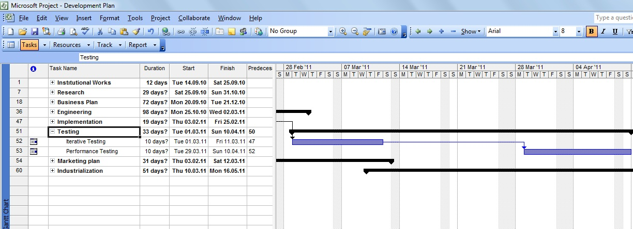
Figure 7: Testing Gantt Chart

2.7 Marketing Plan
Marketing plan is done by Nil Tuğçe Patan. Challenge, costumer analyses, competitor analyses, market segmentation, market strategy are main dividing of marketing plan and duration of them is 30 days.
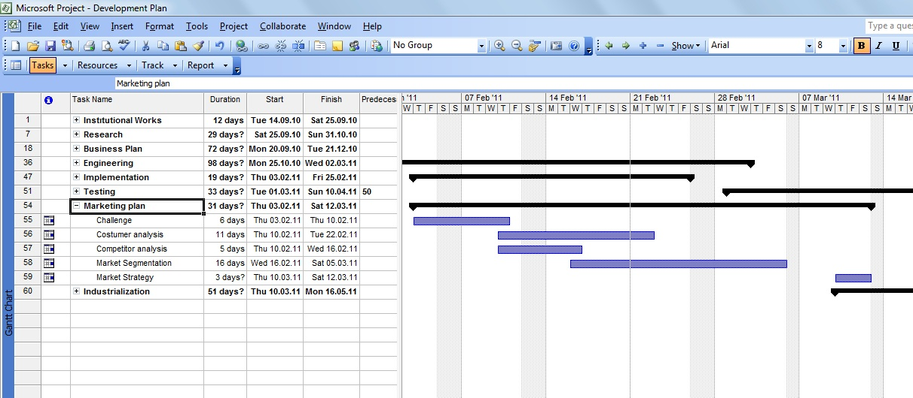

Figure 8: Marketing Pan Gantt Chart

  - Industrialization
Production document, costumer document, quality control is part of it. It involves the vital part of the project and therefore we allocated more time as 51 days.
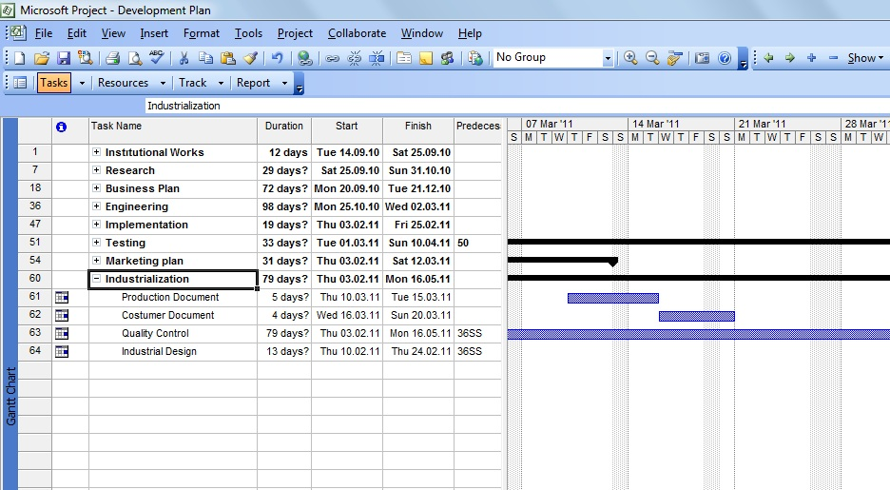

Figure 9: Industrialization Gantt Chart

