
SUNBURST TECHNOLOGY CORPORATION
Team #1-Sunflower
ge401_402@googlegroups.com

SUBASSEMBLY SPECIFICATION REPORT
23.11.2010

Nil Tuğçe Patan-IE(MAN)
İrem Akdaş-IE
Ali Öztaş-CS
Berkay Öğdük-CS
Betül Örün-EE
Tuğçe Kartalkanat-EE

Bilkent University
06800 Ankara

Version 1.1
Table of Contents

1. GENERAL INFORMATION ......………………………………………….….....3
1.1 Operating Environment..............................................................................3
1.2 Software Structures....................................................................................4
1.3 User Interfaces...........................................................................................4

2. MAIN BLOCKS OF SUNFLOWER…..................................................................6
2.1 System Block Diagram...............................................................................6
2.2 Product Tree................................................................................................8
2.1.1 Product Tree of Sunflower...........................................................8
2.1.2 Subassembly Product Trees..........................................................8

3. SUBASSEMBLY SPECIFICATIONS......……………………….….....................9
3.1 SF-100002: Parasol Body...........................................................................9
3.2 SF-100003: PC-104 Embedded PC Module …………........................….9
3.3 SF-100004: Rechargeable Eurostar Nano Gel Battery..............................10
3.4 SF-100006: DC Multifunctional Motor System.........................................11
3.5 SF-100010: Logitech Webcam C160.........................................................12
3.6 SF-100011: ModaCar Cyclone 470090 Rain Sensor.................................12

4. REFERENCES........................................................................................................14

- GENERAL INFORMATION
Sunflower is an innovative parasol that protects the users against burning sunlight and rain without requiring any effort from the users. It can be opened or closed using the RS485 serial port of a computer in the main control room. The main functions of the Sunflower are achieved via rain sensor and image processing to detect the direction of the sun.
The sunflower provides shadow continuously by following the sun. The direction of the sun is detected using a camera and doing image processing. The body of the parasol is designed to move in accordance with the rotating movement.
Considering different weather conditions, we determined that the Sunflower should not be useful only when the weather is sunny. Therefore, we added the rain sensitivity to its functions by using rain sensor. The aim is that; the parasol will be open if it is closed when the rain begins. The important point is that, its speed is determined to prevent the opening structure from disturbing the consumers who sit under the Sunflower.
The design issues such as colour choice, size preference are optional and up to the consumer demands.

  - Operating Environment
The Sunflower is designed to be used outdoors: beaches, hotels, cafes etc. Therefore, it operates within temperatures 0 to 60 Celsius degrees.
The system will use DC current supplied by a rechargeable battery. The operating voltage will be 12 Vdc.

1.2 Software Structures
The operating system in which we control the mechanism of our product is not limited because it works not only in Windows but also MacOS, Linux etc. Our programming language is Java. So we don’t have any restrictions for the screen format. That implies also that any computer that has JDK environment can control the system.

1.3 User Interfaces
The product can be turned on or off and can be controlled from a computer in the main control room over the RS485 serial port connection. The real users, in this case the customers in hotels, cafes etc., do not have any interaction with the sensors, motors, PC module or serial port. These pieces are hidden in boxes.
Any computer that has RS232 serial port or USB port is capable of controlling the sunflower system because our program can only be used over these connection ports. RS 232 or USB port is converted to RS 485 by a converter in order to send data over longer distances without losing any data.
The main control room interface is window based, which can be used without any problems on 800*600 or higher resolution capable computers. User selects the port that the system is connected to, and after that a new window appears to select the parasol and operation. In the new window, the user can use mouse or keyboard to control the system.
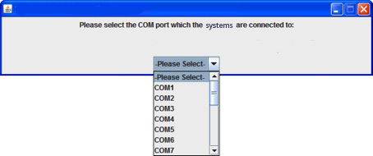
Figure 1: PC Interface Window – 1

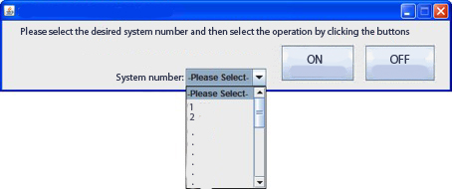
Figure 2: PC Interface Window - 2

In general, the real users are not dealing with anything. The user of the computer in the main control room is dealing with a simple and easy-to-use interface.

- MAIN BLOCKS OF THE SYSTEM
The Sunflower system consists of four main blocks: main controller system, motor system, sensors, and serial port connection.
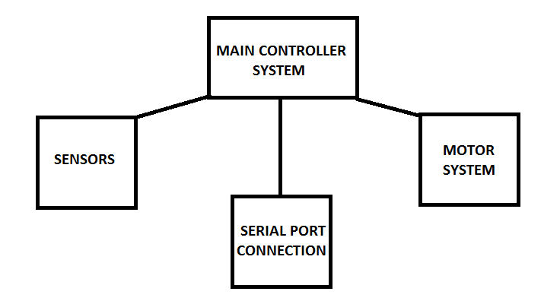
Figure 3: Main Blocks of the System

2.1 System Block Diagram
As can be seen from the system block diagram below, the main controller system, which is PC104 embedded PC module, acts as a brain. It arranges the relationships between other blocks.
When the system is turned on from the main control room by using the RS485 serial port connection, the first motor uses the energy to open the parasol. The sensors start making measurements and immediately share it with the PC module. If there is no rain, the camera detects the angle and direction of the incoming sunlight. According to the data provided by the camera, the second motor inclines the parasol body and the third motor rotates it. When the rain sensor senses the rain, the parasol becomes perpendicular to the ground.
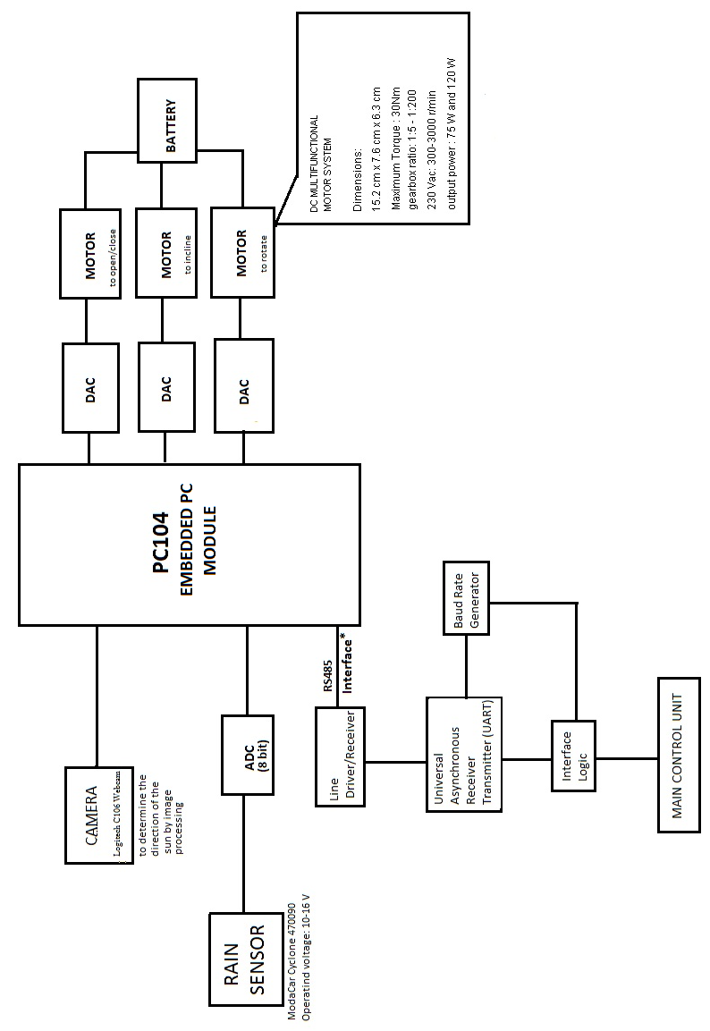Figure 4: System Block Diagram
  - Product Tree
    - Product Tree of Sunflower
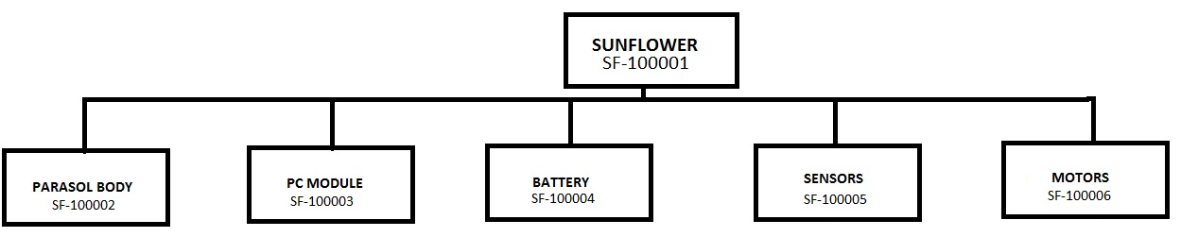
Figure 5: Product Tree
2.2.2 Subassembly Product Trees
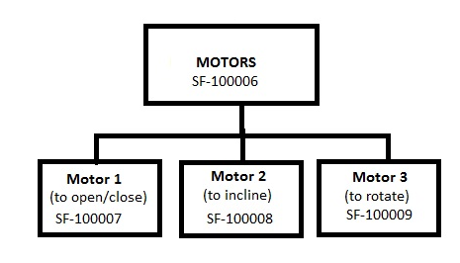
Figure 6: Subassembly Product Tree of Motor System
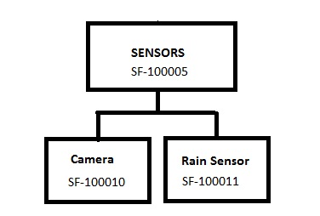
Figure 7: Subassembly Product Tree of Sensors

3. SUBASSEMBLY SPECIFICATIONS
3.1 SF-100002: Parasol Body
Parasol diameter: 3 meters
Parasol area: 7.069
Height of the parasol: 2 meters
Weight of the parasol: 4 kg
Wind speed: 40 km/h
Resistance constant of the parasol: 0.2
Wind load(newton): 109.519
Wind load(kg): 11.164 [1]

3.2 SF-100003: PC-104 Embedded PC Module
Dimensions: 90 x 96mm (3.6" x 3.8")
Height: 15mm (0.6")
Operating temperature range: 0 to 60 ºC (Extended temperature range versions available)
Power supply: Single +5V only
Power consumption: less than 6W

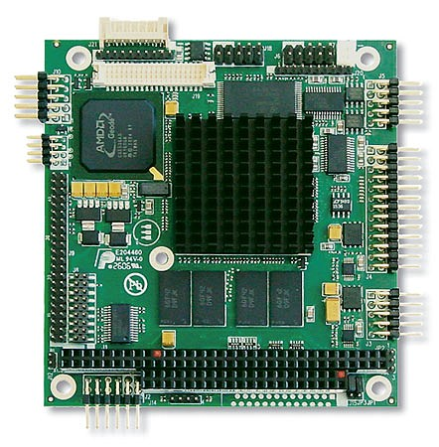
Figure 8: PC/104 Embedded PC Module[2]
3.3 SF-100004: Rechargeable Eurostar Nano Gel Battery
Width x Height x Depth: 87 mm x 151 mm x 130 mm
Weight: 4.4 kg
DC Voltage: 12 V
DC Current : 12 A
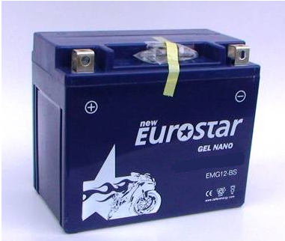
Figure 9: Eurostar Nano Gel Battery [3]
3.4 SF-100006: DC Multifunctional Motor System
3 pieces of multifunctional plug and use DC motors are used in this product. One of the motors is used to open or close the parasol, one is to used incline the body according to the incoming angle of the sunlight and the other is used to rotate the body according to the direction of the sunlight.

Width x Height x Depth: 15.2 cm x 7.6 cm x 6.3 cm
Weight: 3.0 kg
Maximum Torque: 30 Nm
Gearbox ratio: 1:5-1:200
Input voltage: 12 V
Output power: 75W or 120W

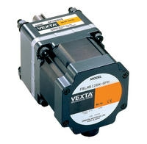
Figure 10: DC Multifunctional Motor [4]

3.5 SF-100010: Logitech Webcam C160
In order to provide continuous shade, a camera is used to detect the direction of sunlight by image processing. Since sunlight is the most powerful source of light on the earth, it is sufficient to use a basic webcam to detect the sunlight. On the other hand, it is necessary to protect the camera against the burning effect of the sunlight. An enduring structural box and a filter will be used to protect the camera.

Width x Height x Depth: 7.8 x 21 x 21 mm
Figure 11: Logitech Webcam C160 [5]

3.6 SF-100011: ModaCar Cyclone 470090 Rain Sensor
The rain sensor reacts in 10 miliseconds when a rain drop ( 0.005 ml water ) falls onto the parasol.
Dimensions: 85 x 115 x 30 mm
Operating Voltage: 10-16 Vdc
Current consumption: 400 mA/1 A
Relay current: 20 A
Perception Sensitivity: 0.005 ml (water)

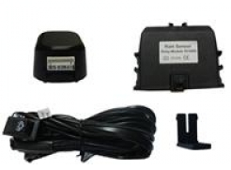
Figure 12: ModaCar Cyclone 470090 Rain Sensor [6]

4. REFERENCES

[1] Wind Load Calculator
<” http://www.asyasat.com/calc.aspx?mid=12&mcid=3&pt=Enlem-Boylam%20ve%20uydu%20a%C3%A7%C4%B1s%C4%B1na%20g%C3%B6re%20anten%20a%C3%A7%C4%B1s%C4%B1%20hesaplama=”>

[2] PC/104 Embedded PC Module
<” http://www.eurotech-inc.com/single-board-computer-geode-pc104-cpu1233.asp=”>

[3] Eurostar Nano Gel Battery
<”http://www.akudunyasi.com/Eurostar-Nano-Gel-Motor-Akusu-12Volt-12Amper-Aku-012V-0012Ah,PR-2608.html=”>

[4] DC Multifunctional Motor System
<”http://www.temsan.org/orientalmotor/id2.htm=”>

[5] Logitech Webcam C160
<”http://channel.logitech.com/storage/DataSheet/48DC532B5A7D5EFDC125775200608173.pdf=”>

[6] ModaCar Cyclone 470090 Rain Sensor
<” http://www.modacar.com.tr/urun/modacar-cyclone-yagmur-sensoru-470090.aspx=”>

