
SUNBURST TECHNOLOGY CORPORATION
Team #1-Sunflower
ge401_402@googlegroups.com

SUBASSEMBLY SPECIFICATION REPORT
13.12.2010

Nil Tuğçe Patan-IE(MAN)
İrem Akdaş-IE
Ali Öztaş-CS
Berkay Öğdük-CS
Betül Örün-EE
Tuğçe Kartalkanat-EE

Bilkent University
06800 Ankara

Version 2.1
Table of Contents

1. GENERAL INFORMATION ......………………………………………….….....3
1.1 Operating Environment..............................................................................3
1.2 Software Structures....................................................................................4
1.3 User Interfaces...........................................................................................4

2. MAIN BLOCKS OF SUNFLOWER…..................................................................6
2.1 System Block Diagram...............................................................................6
2.2 Product Tree................................................................................................8
2.1.1 Product Tree of Sunflower...........................................................8
2.1.2 Subassembly Product Trees..........................................................8

3. SUBASSEMBLY SPECIFICATIONS......……………………….….....................10
3.1 SF-1100000: Parasol Body.........................................................................10
3.2 SF-1200000: 8051 Microcontroller ….......................................................11
3.3 SF-1330000: Motor System........................................................................12
3.3.1 SF-1331000..................................................................................13
3.3.2 SF-1332000/1333000...................................................................14
3.4 SF-1400000: Sun Sensor.............................................................................14
3.4.1 SF-1420000 LDRs.......................................................................14
3.4 SF-1500000: ModaCar Cyclone 470090 Rain Sensor................................16
3.5 SF-1600000: Rechargeable Eurostar Nano Gel Battery.............................17

4. REFERENCES..........................................................................................................18

- GENERAL INFORMATION
Sunflower is an innovative parasol that protects the users against burning sunlight and rain without requiring a considerable effort from the users. It can be opened or closed using the buttons on it. The main functions of the Sunflower are achieved via rain sensor and light dependent resistors.
Light dependent resistor (LDR) is a photoresistor whose resistance decreases with increasing incident light intensity. It can also be referred to as a photoconductor [1]. In sunflower, LDRs are used to decide the position of the parasol. The system consists of four light dependent resistors separated by a separator. This system is placed to the top of the parasol. Each LDR sends the data of exposed sun intensity to microprocessor. According to these data, parasol will bend until all LDRs get sunlight in equal intensity.
Considering different weather conditions, we determined that the Sunflower should not be useful only when the weather is sunny. Therefore, we added the rain sensitivity to its functions by using rain sensor. The aim is that; the parasol will become totally perpendicular to the ground when the rain begins. The important point is that, its speed is determined to prevent the opening structure from disturbing the consumers who sit under the Sunflower.
The design issues such as colour choice, size preference are optional and up to the consumer demands.

  - Operating Environment
The Sunflower is designed to be used outdoors: beaches, hotels, cafes etc. Therefore, it operates within temperatures 0 to 60 Celsius degrees.
The system will use DC current supplied by a rechargeable battery. The operating voltage will be 24 Vdc.

1.2 Software Structures
Since the software structure of the parasol has to be simple and easy-to-use and 8051 Microcontroller is used to control the product, Assembly is chosen to be the programming language.

1.3 User Interfaces
The real users, in this case the customers in hotels, cafes etc., do not have any interaction with the sensors, motors, PC module or serial port. These pieces are hidden in boxes. In a sunny they, all they have to do is to push two buttons. The first button is the main switch. It prevents unnecessary electricity consumption, while the parasol is not being used. The second button is the on/off button. It is used to start or to stop the operation of the system. Obviously, it can be used only if the first button is pushed. After the second button is pushed to turn the system on, a green LED emits light to indicate that the system is working.
There is another LED, which is necessary for partly cloudy days. If the rain drops and sun shines simultaneously, protecting users from the rain is priority. However, there is a problem with the rain sensor, which is used in the system and no better sensor are available in the market. The problem is that, when the rain stops the surface remains wet for a while and the sensor cannot perceive that there is no rain anymore. This situation might cause a significant error rate in the operation. To prevent this situation, a rain indicator LED and an extra button are used. When the rain begins, the rain indicator LED emits light. The operation of the sun sensor is interrupted and the parasol body becomes totally perpendicular to the ground. When the rain stops, the user has to push a button to interrupt the operation of the rain sensor and to make the sun sensor operate.

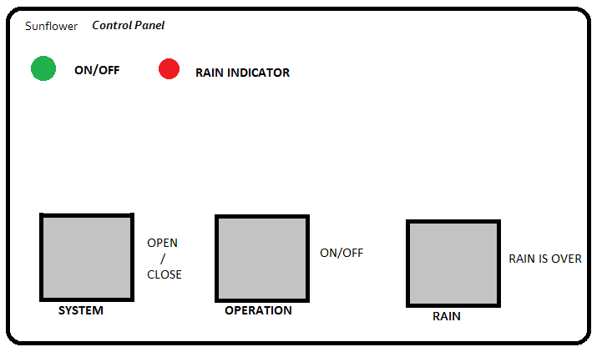
Figure 1: Control Panel

- MAIN BLOCKS OF THE SYSTEM
The Sunflower system consists of four main blocks: main controller system, motor system, sensors, and serial port connection.
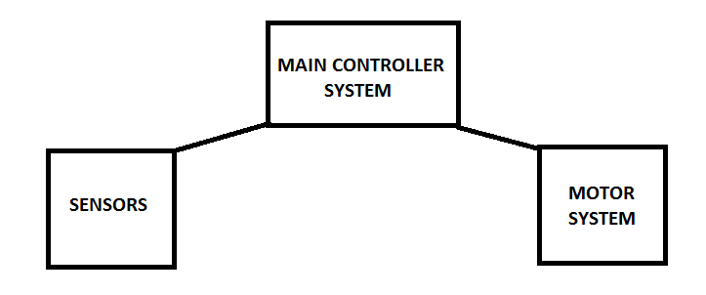
Figure 2: Main Blocks of the System

2.1 System Block Diagram
As can be seen from the system block diagram below, the main controller system, 8051 microcontroller, acts as a brain. It arranges the relationships between other blocks.
When the system is opened by pushing the first button (system button), the electricity is drawn from the battery. After the operation button is pushed, the first motor uses the energy to open the parasol. The sensors start making measurements and immediately share it with the microcontroller. If there is no rain, LDRs detect the angle and direction of the incoming sunlight. According to the data provided by the LDRs, the second motor inclines the parasol body and the third motor rotates it. When the rain sensor senses the rain, the parasol becomes perpendicular to the ground. When the rain stops, the user pushes a button to interrupt the operation of the rain sensor and to make the sun sensor operate.
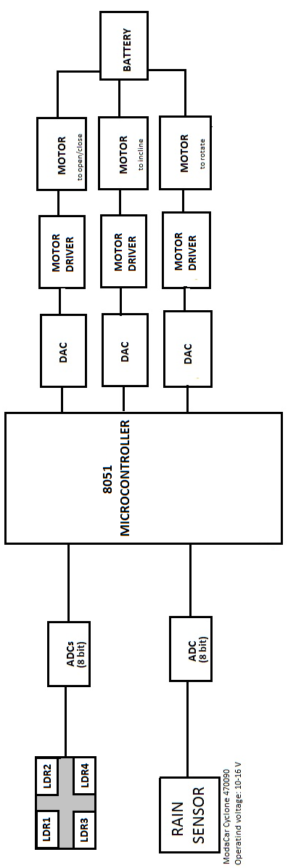
Figure 3: System Block Diagram
  - Product Tree
    - Product Tree of Sunflower
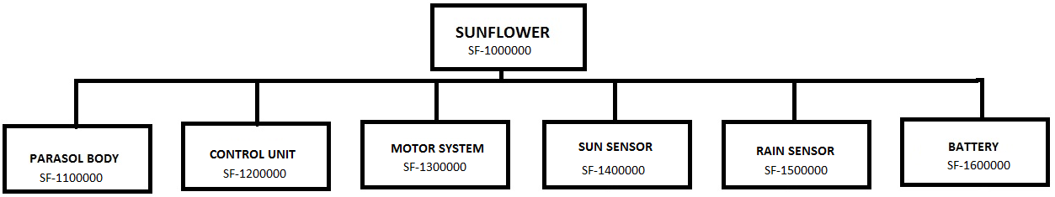
Figure 4: Product Tree
    - Subassembly Product Trees
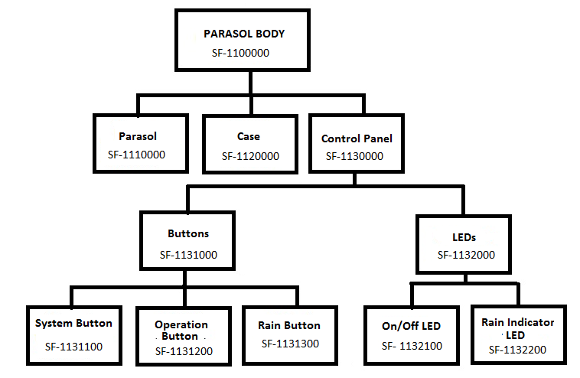
Figure 5: Product Tree of Parasol Body
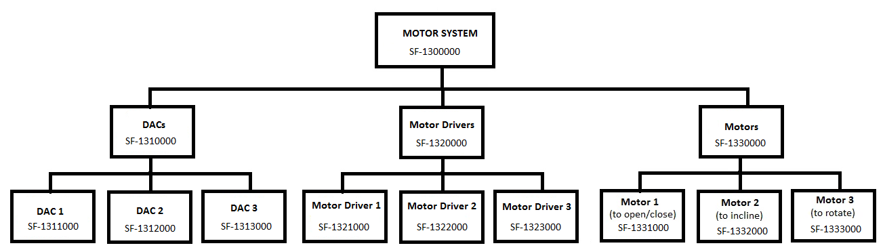
Figure 6: Subassembly Product Tree of Motor System

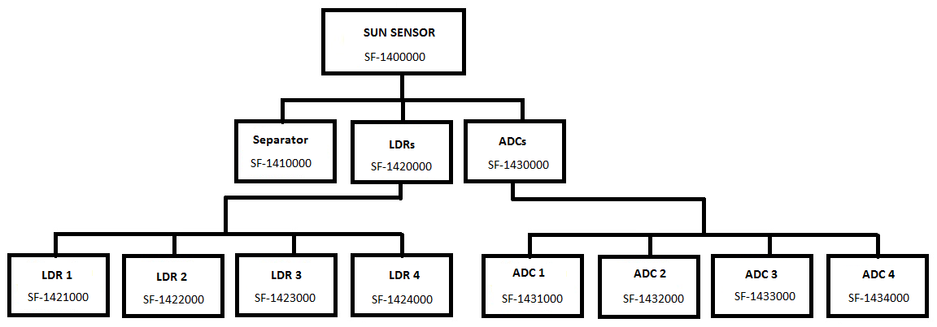
Figure 7: Subassembly Product Tree of Sun Sensor

3. SUBASSEMBLY SPECIFICATIONS
3.1 SF-1100000: Parasol Body
The parasol body consists of the parasol itself, control panel and a case or box to prevent user from interacting with motors, microcontroller etc. The case is necessary in terms of safety and aesthetic. It is positioned at the lower part of the parasol.
The parasol itself should satisfy the expectations from an ordinary parasol in terms of physical characteristics. 3 m diameter and 2 m height are the physical characteristics of most of the ordinary parasols in the market. It should be easy to carry, but resistant to move due to external conditions such as weather conditions, children effects. Therefore, 4 kg weight is appropriate for the parasol, but also a 20 kg base as a weight to put under the parasol is needed.
The parasol body has to endure wind at up to 40 km/h speed. In this case the wind load of the parasol will be approximately 11.2 kg.

Parasol diameter: 3 meters
Parasol area: 7.069
Height of the parasol: 2 meters
Weight of the parasol: 4 kg
Wind speed: 40 km/h
Resistance constant of the parasol: 0.2
Wind load(newton): 109.519
Wind load(kg): 11.164 [2]

3.2 SF-1200000: 8051 Microcontroller
In Sunflower, 8051 microcontroller is used to control the product. 4 pieces of 8-bit ADCs are connected to the input pins of the microcontroller to provide data. Since the parasol will be exposed to high intensity sun ray, the microcontroller should endure high temperature values. 8051 can operate in temperature range -40 – 85 ºC.

Dimensions: 25 x 85 mm
Operating temperature range: -40 to 85 ºC (Extended temperature range versions available)
Power supply: Single +5V
Maximum power consumption: 12W

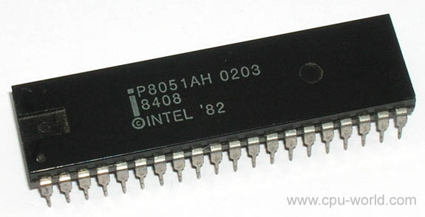
Figure 8: 8051 Microcontroller [3]

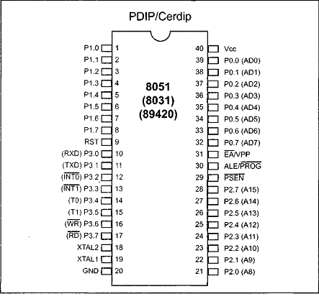
Figure 9 : I/O Pins Scheme of 8051 [3]
3.3 SF-1330000: DC Motors
3 pieces of DC motors are used in this product. One of the motors is used to open or close the parasol, one is to used incline the body according to the incoming angle of the sunlight and the other is used to rotate the body according to the direction of the sunlight. 2 types of motors are used.
Since at 40 km/h wind, the wind load on the parasol is about 11.2 kg, powerful motors are needed. 2 motors, one to rotate and the other to incline, should have torque value about 23 Nm. For the motor that is used to open or close the product approximately 7 Nm torque is sufficient. Additionally, the parasol should open or close slightly in order not to harm users. It is opened or closed in approximately 60 seconds. In order to provide slow opening/closing rate, revolution per minute value of the motor should be relatively low. 9 revolutions per minute is an appropriate value.
The motors introduced below are considered to be used in Sunflower.

3.3.1 SF-1331000
Width x Height x Depth: 6.9 cm x 3.6 cm x 3.6 cm
Weight: 0.3 kg
Maximum Torque: 7.8 Nm = 80 kg.cm
Gearbox ratio: 629:1
Input voltage: 24 V
Revolutions per Minute (RPM): 9
Output power: 5.74 W
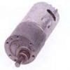
Figure 10: DC Motor [4]

3.3.2 SF-1332000/1333000
Width x Height x Depth: 15.2 cm x 7.6 cm x 6.3 cm
Weight: 3.0 kg
Maximum Torque: 30 Nm
Gearbox ratio: 1:5-1:200
Input voltage: 12 V
Output power: 75W or 120 W
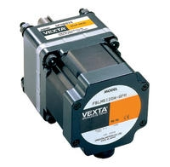
Figure 11: DC Multifunctional Motor [5]

3.4 SF-1400000: Sun Sensor
The sun sensor consists of 4 LDRs separated by a separator and 4 ADCs. The data is sent from LDR to the microcontroller through ADCs (analog to digital converter).

3.4.1 SF-1420000: LDRs
Light dependent resistor (LDR) is a photoresistor whose resistance decreases with increasing incident light intensity. It can also be referred to as a photoconductor [1].
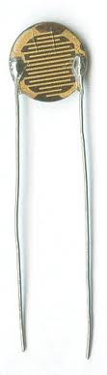
Figure 12: Light Dependent Resistor [1]

In sunflower, LDRs are used to decide the position of the parasol. The system consists of four light dependent resistors separated by a separator. This system is placed at the top of the parasol. Each LDR sends the data of exposed sun intensity to microprocessor. According to these data, parasol will bend until all LDRs get sunlight in equal intensity.

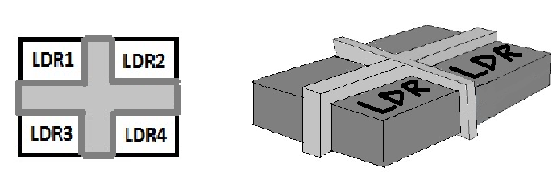
Figure 13: Sun sensor

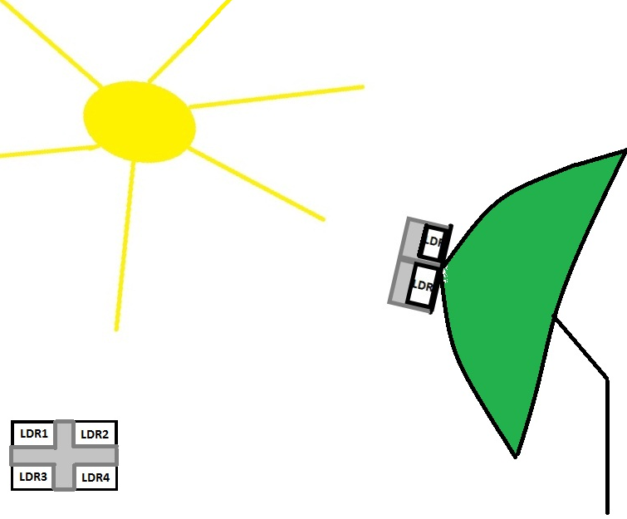
Figure 14: Sun Sensor

3.5 SF-1500000: ModaCar Cyclone 470090 Rain Sensor
When the rain begins, the rain sensor immediately senses it and sends the data to microcontroller. The rain sensor reacts in 10 milliseconds when a rain drop ( 0.005 ml water ) falls onto the parasol.
Dimensions: 85 x 115 x 30 mm
Operating Voltage: 10-16 Vdc
Current consumption: 400 mA/1 A
Relay current: 20 A
Perception Sensitivity: 0.005 ml (water)
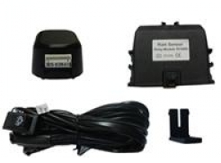
Figure 15: ModaCar Cyclone 470090 Rain Sensor [6]

3.6 SF-1600000: Rechargeable Eurostar Nano Gel Battery
Rechargeable battery is used to supply power to the product.

Width x Height x Depth: 87 mm x 151 mm x 130 mm
Weight: 4.4 kg
DC Voltage: 12 V
DC Current : 12 A
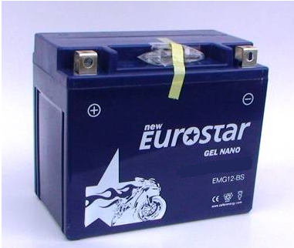
Figure 16: Eurostar Nano Gel Battery [7]

- REFERENCES

[1] Light Dependent Resistor
<” http://en.wikipedia.org/wiki/Light_Dependent_Resistor=”>

[2] Wind Load Calculator
<” http://www.asyasat.com/calc.aspx?mid=12&mcid=3&pt=Enlem-Boylam%20ve%20uydu%20a%C3%A7%C4%B1s%C4%B1na%20g%C3%B6re%20anten%20a%C3%A7%C4%B1s%C4%B1%20hesaplama=”>

[3] 8051 Microcontroller
<” http://www.cpu-world.com/CPUs/8051/index.html=”>

[4] DC Motor
<”http://www.allproducts.com/manufacture97/qijintai/product3.jpg=”>

[5] DC Multifunctional Motor System
<”http://www.temsan.org/orientalmotor/id2.htm=”>

[6] ModaCar Cyclone 470090 Rain Sensor
<” http://www.modacar.com.tr/urun/modacar-cyclone-yagmur-sensoru-470090.aspx=”>

[7] Eurostar Nano Gel Battery
<”http://www.akudunyasi.com/Eurostar-Nano-Gel-Motor-Akusu-12Volt-12Amper-Aku-012V-0012Ah,PR-2608.html=”>

